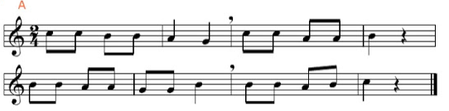

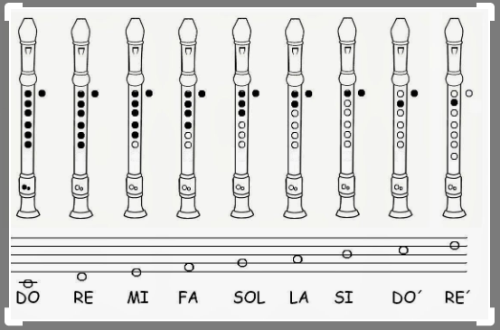

Take your time, practice as much as you can (or as much as you are allowed at home) and then record yourself and **send me the video.**